Kamesh.S
192521358
Operating System
Lab Experiments

1.Implement C program for producer consumer for cooperation of process

PROGRAM:

#include <stdio.h>

int buffer[5];
int in = 0, out = 0, count = 0;

void produce(int item)
{
if (count == 5)
{
printf("Buffer is Full!\n");
return;
}

buffer[in] = item;
in = (in + 1) % 5;
count++;

printf("Produced: %d\n", item);
}

void consume()
{
if (count == 0)
{
printf("Buffer is Empty!\n");
return;
}

printf("Consumed: %d\n", buffer[out]);
out = (out + 1) % 5;
count--;
}

int main()
{
produce(10);
produce(20);
produce(30);

consume();
consume();

produce(40);

consume();
consume();

return 0;
}

Output:
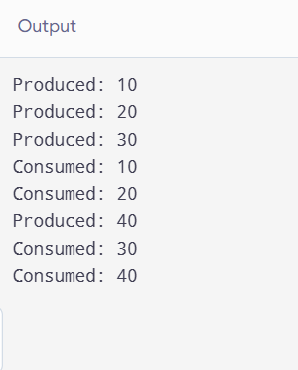

2.Give as a implementation os socket programming using TCP / UDP

Program:

AIM
To implement socket programming using TCP (Transmission Control Protocol) and UDP (User Datagram Protocol) to establish communication and exchange data between a client and a server.

PROCEDURE
- Create a socket using the appropriate socket function.
- Assign an IP address and port number to the server.
- For TCP, establish a connection between the client and server.
- For UDP, send and receive data using datagrams without establishing a connection.
- Send a message from the client to the server.
- Receive the message at the server and display it.
- Close the socket after communication is completed.

Program:
TCP Socket
#include <stdio.h>
#include <string.h>

int main() {
char clientMessage[100] = "Hello from TCP Client";
char serverMessage[100] = "Hello from TCP Server";

printf("TCP SOCKET PROGRAMMING\n");
printf("----------------------\n");

printf("Server started successfully.\n");
printf("Server is waiting for client...\n");

printf("Client connected to server.\n");

printf("\nClient sends: %s\n", clientMessage);
printf("Server receives: %s\n", clientMessage);

printf("\nServer sends: %s\n", serverMessage);
printf("Client receives: %s\n", serverMessage);

printf("\nTCP communication completed.\n");
printf("Connection closed successfully.\n");

return 0;
}
Output:
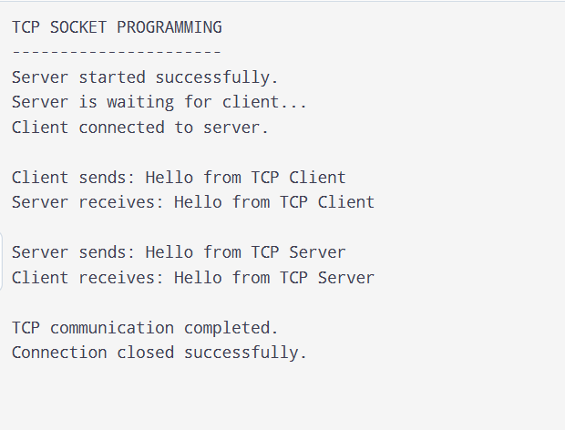
UDP:
#include <stdio.h>
#include <string.h>

int main() {
char clientMessage[100] = "Hello from UDP Client";
char serverMessage[100] = "Hello from UDP Server";

printf("UDP SOCKET PROGRAMMING\n");
printf("----------------------\n");

printf("UDP Server started successfully.\n");

printf("\nClient sends: %s\n", clientMessage);
printf("Server receives: %s\n", clientMessage);

printf("\nServer sends: %s\n", serverMessage);
printf("Client receives: %s\n", serverMessage);

printf("\nUDP communication completed.\n");

return 0;
}
Output:
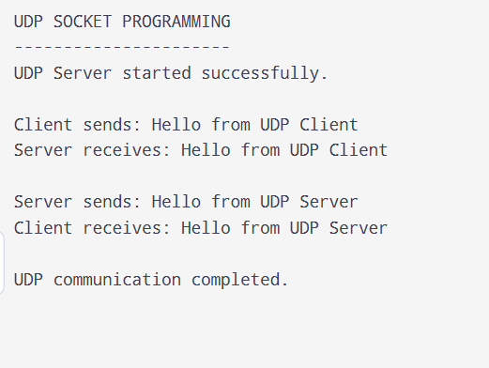

3.Give as a Implementing the java programming using multi threading

1. Aim
To write and execute a Java program using multithreading to perform multiple tasks concurrently.

2. Algorithm
- Start the program.
- Create a class that extends the Thread class.
- Override the run() method to define the task performed by the thread.
- Create two thread objects.
- Start both threads using the start() method.
- Allow both threads to execute concurrently.
- Display the output produced by each thread.
- Stop the program.
Program:
public class MyThread extends Thread {

MyThread(String name) {
super(name);
}

public void run() {
for (int i = 1; i <= 5; i++) {
System.out.println(getName() + " - Count: " + i);

try {
Thread.sleep(500);
} catch (InterruptedException e) {
Thread.currentThread().interrupt();
return;
}
}
}

public static void main(String[] args) {
MyThread t1 = new MyThread("Thread 1");
MyThread t2 = new MyThread("Thread 2");

t1.start();
t2.start();

try {
t1.join();
t2.join();
} catch (InterruptedException e) {
Thread.currentThread().interrupt();
}

System.out.println("Both threads completed.");
}
}

Output:
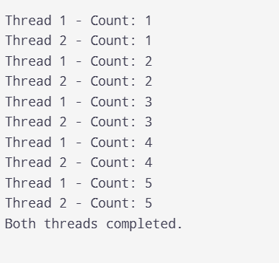

4.Give as a Implementation process creation using system call:

1. Aim
To write and execute a C program to demonstrate process creation using the fork() system call in an operating system.

2. Algorithm
- Start the program.
- Display the process ID of the parent process.
- Call the fork() system call to create a child process.
- Check the return value of fork().
- If the return value is 0, execute the child process statements.
- If the return value is greater than 0, execute the parent process statements.
- Display the process IDs.
- Terminate the program.
Program:

#include <stdio.h>
#include <stdlib.h>
#include <unistd.h>
#include <sys/types.h>
#include <sys/wait.h>

int main(void) {
pid_t pid = fork();

if (pid < 0) {
perror("Fork failed");
return EXIT_FAILURE;
}

if (pid == 0) {
printf("Child Process Created Successfully\n");
printf("Child Process ID: %ld\n", (long)getpid());
printf("Parent Process ID: %ld\n", (long)getppid());
return EXIT_SUCCESS;
}

wait(NULL);

printf("Parent Process Executed Successfully\n");
printf("Parent Process ID: %ld\n", (long)getpid());
printf("Child Process ID: %ld\n", (long)pid);

return EXIT_SUCCESS;
}
Output:
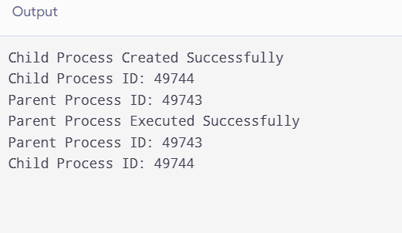

5.Implement as a Copy File Contents Using System Calls:

1. Aim
To write a C program to copy the contents of one file into another file using system calls such as open(), read(), write(), and close().

2. Algorithm
- Start the program.
- Open the source file in read-only mode.
- Create or open the destination file in write mode.
- Read the source file contents using read().
- Write the contents into the destination file using write().
- Repeat until the end of the source file is reached.
- Close both files using close().
- Display the success message and stop.
Program:

#include <stdio.h>
#include <stdlib.h>
#include <fcntl.h>
#include <unistd.h>

int main(void) {
int source, destination;
char buffer[1024];
ssize_t n;

source = open("/tmp/source.txt",
O_WRONLY | O_CREAT | O_TRUNC, 0644);

if (source == -1) {
perror("Source creation failed");
return 1;
}

const char text[] =
"Operating System\n"
"System Calls\n"
"File Handling in C\n";

if (write(source, text, sizeof(text) - 1) == -1) {
perror("Source writing failed");
close(source);
return 1;
}

close(source);

source = open("/tmp/source.txt", O_RDONLY);
if (source == -1) {
perror("Source opening failed");
return 1;
}

destination = open("/tmp/destination.txt",
O_WRONLY | O_CREAT | O_TRUNC, 0644);

if (destination == -1) {
perror("Destination opening failed");
close(source);
return 1;
}

while ((n = read(source, buffer, sizeof(buffer))) > 0) {
ssize_t offset = 0;

while (offset < n) {
ssize_t written = write(
destination, buffer + offset, n - offset
);

if (written <= 0) {
perror("Copy failed");
close(source);
close(destination);
return 1;
}

offset += written;
}
}

if (n == -1) {
perror("Reading failed");
close(source);
close(destination);
return 1;
}

close(source);
close(destination);

printf("File contents copied successfully.\n");
printf("Source: /tmp/source.txt\n");
printf("Destination: /tmp/destination.txt\n");
return 0;
}
Output:
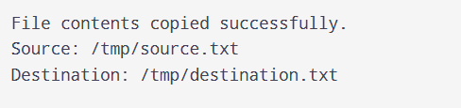
6. Design a CPU scheduling program with C using First Come First Served technique with the following considerations.
a. All processes are activated at time 0.
b. Assume that no process waits on I/O devices
1. Aim
To write and execute a C program to implement the First Come First Served (FCFS) CPU scheduling algorithm, assuming that all processes arrive at time 0 and no process waits for I/O devices.
2. Algorithm
- Start the program.
- Read the number of processes.
- Read the burst time of each process.
- Set the arrival time of all processes to 0.
- Schedule the processes in the order they are entered.
- Calculate the waiting time for each process.
- Calculate the turnaround time for each process.
- Calculate the average waiting time and average turnaround time.
- Display the results and stop.
Program:

#include <stdio.h>

int main() {
int n, i;
int bt[20], wt[20], tat[20];
float total_wt = 0, total_tat = 0;

printf("Enter number of processes: ");
scanf("%d", &n);

if (n <= 0 || n > 20) {
printf("Invalid number of processes.\n");
return 1;
}

printf("Enter burst time of each process:\n");
for (i = 0; i < n; i++) {
printf("P%d: ", i + 1);
scanf("%d", &bt[i]);

if (bt[i] < 0) {
printf("Burst time cannot be negative.\n");
return 1;
}
}

wt[0] = 0;
tat[0] = bt[0];

for (i = 1; i < n; i++) {
wt[i] = wt[i - 1] + bt[i - 1];
tat[i] = wt[i] + bt[i];
}

printf("\nProcess\tBurst Time\tWaiting Time\tTurnaround Time\n");

for (i = 0; i < n; i++) {
printf("P%d\t%d\t\t%d\t\t%d\n",
i + 1, bt[i], wt[i], tat[i]);

total_wt += wt[i];
total_tat += tat[i];
}

printf("\nAverage Waiting Time = %.2f",
total_wt / n);
printf("\nAverage Turnaround Time = %.2f\n",
total_tat / n);

return 0;
}
Output:
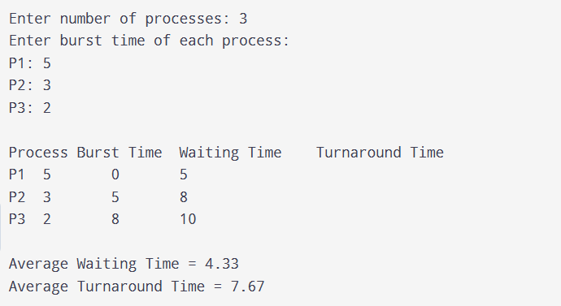
7. Preemptive Priority Scheduling Algorithm in C
1. Aim
To write and execute a C program to implement the Preemptive Priority CPU Scheduling Algorithm and calculate the waiting time, turnaround time, and their averages for all processes.
2. Algorithm
- Start the program.
- Read the number of processes.
- Read the arrival time, burst time, and priority of each process.
- Initialize the remaining burst time for each process.
- Select the highest-priority process among the arrived processes.
- Execute the selected process for one time unit.
- If a higher-priority process arrives, preempt the current process.
- Repeat until all processes finish execution.
- Calculate waiting time and turnaround time for each process.
- Display the process details and average times.
- Stop the program.
Program:

#include <stdio.h>

int main(void) {
int n, i, time = 0, completed = 0;
int at[20], bt[20], pr[20], rem[20];
int ct[20], wt[20], tat[20];
int idx;
float total_wt = 0, total_tat = 0;

printf("Enter number of processes: ");
scanf("%d", &n);

if (n <= 0 || n > 20) {
printf("Invalid number of processes.\n");
return 1;
}

for (i = 0; i < n; i++) {
printf("Enter arrival time, burst time and priority for P%d: ",
i + 1);
scanf("%d %d %d", &at[i], &bt[i], &pr[i]);

if (at[i] < 0 || bt[i] <= 0 || pr[i] < 0) {
printf("Invalid input.\n");
return 1;
}

rem[i] = bt[i];
}

while (completed < n) {
idx = -1;

for (i = 0; i < n; i++) {
if (at[i] <= time && rem[i] > 0) {
if (idx == -1 || pr[i] < pr[idx] ||
(pr[i] == pr[idx] && at[i] < at[idx])) {
idx = i;
}
}
}

if (idx == -1) {
time++;
continue;
}

rem[idx]--;
time++;

if (rem[idx] == 0) {
ct[idx] = time;
tat[idx] = ct[idx] - at[idx];
wt[idx] = tat[idx] - bt[idx];
completed++;
}
}

printf("\nProcess\tAT\tBT\tPriority\tCT\tWT\tTAT\n");

for (i = 0; i < n; i++) {
printf("P%d\t%d\t%d\t%d\t\t%d\t%d\t%d\n",
i + 1, at[i], bt[i], pr[i],
ct[i], wt[i], tat[i]);

total_wt += wt[i];
total_tat += tat[i];
}

printf("\nAverage Waiting Time = %.2f\n", total_wt / n);
printf("Average Turnaround Time = %.2f\n", total_tat / n);

return 0;
}
Output:
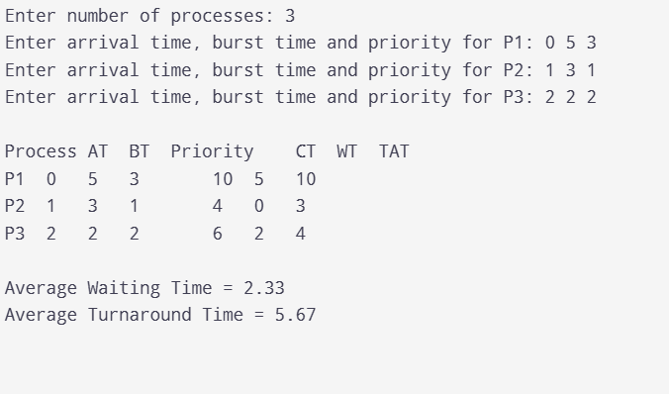

9.Construct a C program to implement a non-preemptive SJF algorithm.
Aim:
To write and execute a C program to implement the Non-Preemptive Shortest Job First (SJF) CPU Scheduling Algorithm and calculate the waiting time, turnaround time, and their averages for all processes.
2. Algorithm
- Start the program.
- Read the number of processes.
- Read the arrival time and burst time of each process.
- Select the process with the shortest burst time among the processes that have arrived and are not completed.
- Execute the selected process until it finishes.
- Calculate its completion time, waiting time, and turnaround time.
- Repeat until all processes are completed.
- Calculate the average waiting time and average turnaround time.
- Display the results and stop.
Program:

#include <stdio.h>

int main(void) {
int n, i, time = 0, completed = 0, idx;
int at[20], bt[20], ct[20], wt[20], tat[20];
int done[20] = {0};
float total_wt = 0, total_tat = 0;

printf("Enter number of processes: ");
scanf("%d", &n);

if (n <= 0 || n > 20) {
printf("Invalid number of processes.\n");
return 1;
}

for (i = 0; i < n; i++) {
printf("Enter arrival time and burst time for P%d: ", i + 1);
scanf("%d %d", &at[i], &bt[i]);

if (at[i] < 0 || bt[i] <= 0) {
printf("Invalid input.\n");
return 1;
}
}

while (completed < n) {
idx = -1;

for (i = 0; i < n; i++) {
if (!done[i] && at[i] <= time) {
if (idx == -1 || bt[i] < bt[idx] ||
(bt[i] == bt[idx] && at[i] < at[idx])) {
idx = i;
}
}
}

if (idx == -1) {
time++;
continue;
}

time += bt[idx];
ct[idx] = time;
tat[idx] = ct[idx] - at[idx];
wt[idx] = tat[idx] - bt[idx];

done[idx] = 1;
completed++;
}

printf("\nProcess\tAT\tBT\tCT\tWT\tTAT\n");

for (i = 0; i < n; i++) {
printf("P%d\t%d\t%d\t%d\t%d\t%d\n",
i + 1, at[i], bt[i], ct[i], wt[i], tat[i]);

total_wt += wt[i];
total_tat += tat[i];
}

printf("\nAverage Waiting Time = %.2f\n", total_wt / n);
printf("Average Turnaround Time = %.2f\n", total_tat / n);

return 0;
}
Output:
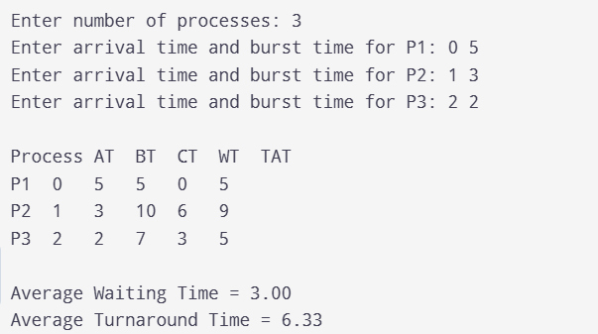
9. Construct a C program to simulate Round Robin scheduling algorithm with C.
Aim:
To write and execute a C program to simulate the Round Robin (RR) CPU Scheduling Algorithm and calculate the waiting time, turnaround time, and their averages for all processes.
2. Algorithm
- Start the program.
- Read the number of processes and their burst times.
- Read the time quantum.
- Initialize the remaining burst time of each process.
- Execute each process for the time quantum or until it finishes.
- If a process is not completed, place it at the end of the ready queue.
- Repeat until all processes are completed.
- Calculate the waiting time and turnaround time.
- Display the results and stop.
Program:

#include <stdio.h>

int main(void) {
int n, q, i, time = 0, completed;
int bt[20], rem[20], wt[20], tat[20], ct[20];
float total_wt = 0, total_tat = 0;

printf("Enter number of processes: ");
scanf("%d", &n);

if (n <= 0 || n > 20) {
printf("Invalid number of processes.\n");
return 1;
}

for (i = 0; i < n; i++) {
printf("Enter burst time for P%d: ", i + 1);
scanf("%d", &bt[i]);

if (bt[i] <= 0) {
printf("Burst time must be positive.\n");
return 1;
}

rem[i] = bt[i];
}

printf("Enter time quantum: ");
scanf("%d", &q);

if (q <= 0) {
printf("Time quantum must be positive.\n");
return 1;
}

completed = 0;

while (completed < n) {
for (i = 0; i < n; i++) {
if (rem[i] > 0) {
if (rem[i] > q) {
time += q;
rem[i] -= q;
} else {
time += rem[i];
rem[i] = 0;
ct[i] = time;
completed++;
}
}
}
}

printf("\nProcess\tBurst Time\tWaiting Time\tTurnaround Time\n");

for (i = 0; i < n; i++) {
tat[i] = ct[i];
wt[i] = tat[i] - bt[i];

printf("P%d\t%d\t\t%d\t\t%d\n",
i + 1, bt[i], wt[i], tat[i]);

total_wt += wt[i];
total_tat += tat[i];
}

printf("\nAverage Waiting Time = %.2f\n", total_wt / n);
printf("Average Turnaround Time = %.2f\n", total_tat / n);

return 0;
}
Output:
